+

Biology

Topic 16 – Circulatory System
Power Notes 1

SC.912.L.14.36 - Factors Affecting Blood Flow  ______________________________  ______________________________  ______________________________  ______________________________  ______________________________  ______________________________  ______________________________  ______________________________  ______________________________  ______________________________  ______________________________  ______________________________  ______________________________  ______________________________  ______________________________  ______________________________  ______________________________  ______________________________  ______________________________  ______________________________  ______________________________  ______________________________  ______________________________  ______________________________  ______________________________  ______________________________  ______________________________  ______________________________  ______________________________  ______________________________  ______________________________  ______________________________  ______________________________ | MAIN IDEA: The circulatory system has several important functions.  Functions of the Circulatory System  1.  2.  3.  MAIN IDEA: The heart pumps blood through two main pathways.  Systemic Circulation Pulmonary Circulation  MAIN IDEA: The tissues and structures of the heart make it an efficient pump.  Left Atrium  Pulmonary Artery  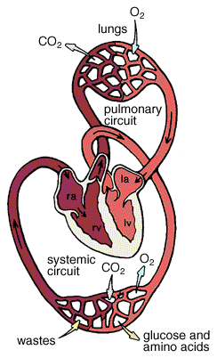  Right Atrium  Pulmonary Vein  Veins  Arteries  Right Ventricle  Left Ventricle  \\\

