+

Biology

Topic 16 – Circulatory System
Power Notes 2

SC.912.L.14.36 - Factors Affecting Blood Flow  ______________________________  ______________________________  ______________________________  ______________________________  ______________________________  ______________________________  ______________________________  ______________________________  ______________________________  ______________________________  ______________________________  ______________________________  ______________________________  ______________________________  ______________________________  ______________________________  ______________________________  ______________________________  ______________________________  ______________________________  ______________________________  ______________________________  ______________________________  ______________________________  ______________________________  ______________________________  ______________________________  ______________________________  ______________________________  ______________________________  ______________________________  ______________________________  ______________________________ | MAIN IDEA: Arteries, veins, and capillaries transport blood to all parts of the body.  Arteries Capillaries Veins  What They Have in Common:  MAIN IDEA: Blood pressure is a measure of the force with which blood pushes against an artery wall.  Blood pressure is:  Factors that may affect blood pressure include:  Hypertension is:  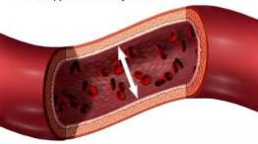  MAIN IDEA: Lifestyle plays a key role in circulatory diseases.  Cardiovascular diseases are:  Atherosclerosis: Heart Attack, Stroke:

