Name: ___________________________ Period: ____ Date: ________
Learning Objectives: Students will (1) summarize the steps of translation and (2) explain the relationship between genes and proteins.
Essential Question: Suppose the DNA sequence GCTATATCG was changed to GCGATATCG.
- How would the products of transcription and translation be affected?
- How does the DNA nucleotide sequence determine the amino acid sequence in a protein?
From DNA to Proteins
WHAT IS THE GENETIC CODE?
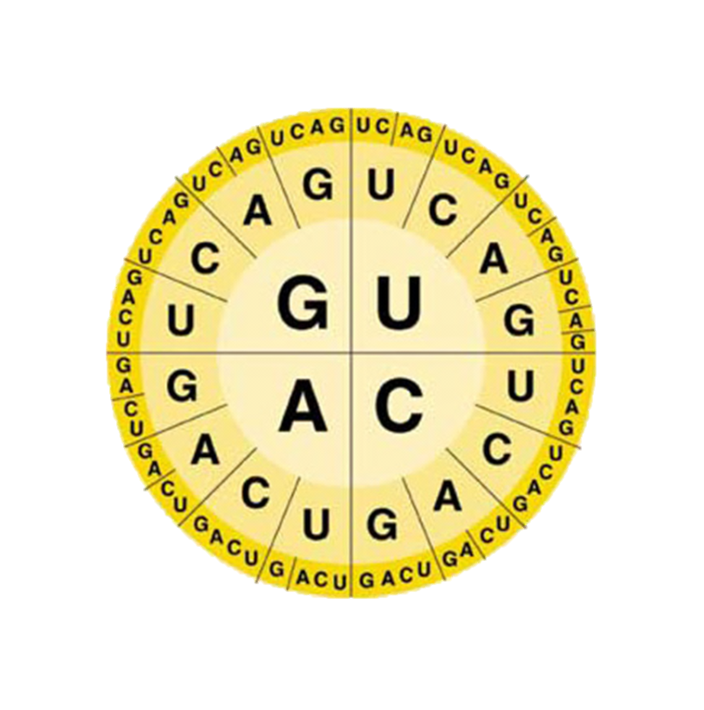
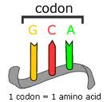
The “language” of mRNA instructions to make proteins is called the ________________. Recall that RNA contains four different bases: A, U, G, and C. The genetic code is read three
letters at a time, so that each “word” is three bases long. Each three-letter word is known as codon. A _____________ consists of three consecutive nucleotides that specify a single amino acid that is to be added to the polypeptide. Because there are four different bases,
there are 64 possible three-base codons (4x4x4=64). The Universal Genetic Code chart shows the amino acids to which each of the possible codons correspond.
HOW DOES A CELL INTERPRET DNA?
Consider the following RNA sequence: ^{5’}UCGCACGGU^{3’}
This sequence will be read three bases at a
time as: __ __ __ - __ __ __ - __ __ __
The codons represent the following amino-acids: _____________ - _____________ - _____________
Let’s Practice
Consider the following RNA sequence and identify the amino acids it will code for.
^{5’}AUGCGCUUCUAA^{3’}
Consider the following DNA sequence and identify the amino acids it will code for.
^{3’}CTTGGAATG^{5’}

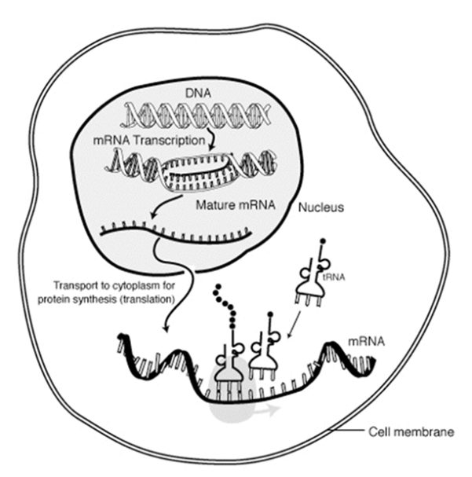
WHAT IS TRANSLATION?
The decoding of an mRNA message into a polypeptide chain is known as _____________________. Translation takes place on __________________. During translation, or protein synthesis, the cell uses information from _______________ to produce _________________.
The cell uses all three main forms of RNA during translation.
Recall and Practice: Briefly describe the function of all three types of RNA.
mRNA: ______________________________________________________________________
tRNA: _______________________________________________________________________
rRNA: _______________________________________________________________________
HOW DOES TRANSLATION WORK?
mRNA is transcribed in the ______________, and then it enters the ________________. Translation begins when a ribosome ___________ to mRNA at a specific area (AUG). The ribosome starts matching tRNA ________________ sequences to the mRNA codon sequence. Each tRNA carries ___________ kind of ___________________.
Each time a new tRNA comes into the ribosome, the amino acid that it was carrying gets added to the elongating ____________________ chain. The ribosome continues until it hits a __________ sequence, and then it releases the polypeptide and the mRNA. The polypeptide forms into its native shape and starts acting as a functional _______________ in the cell.
ESSENTIAL QUESTION:
Essential Question: Suppose the DNA sequence GCTATATCG was changed to GCGATATCG.
- How would the products of transcription and translation be affected?
- How does the DNA nucleotide sequence determine the amino acid sequence in a protein?
________________________________________________________________________________________________________________________________________________________________________________________________________________________________________________________________________________________________________________________________________________________________________________________________________________________________________________________________________
WHAT HAVE I LEARNED?
The synthesis of proteins is a carefully orchestrated and controlled process that begins with a coded message on a DNA molecule. A portion of the DNA molecule is transcribed into mRNA. mRNA contains the instructions for a protein to be built on the ribosomes. The cell goes to a lot of trouble to synthesize proteins correctly because proteins define what the cell look like, how it functions, how it grows, and how it passes this information to its daughter cells. Some of the specific roles played by proteins include enzymatic action, transport, motion, protection, support, communication, and regulation.

- Given the following strand fragments of nucleic acids, identify the polypeptide chains they will code.

  - ACCTAGCGC
  - AAGGUCCUU
  - TTCCGCGAA
  - GUGGUGAGG

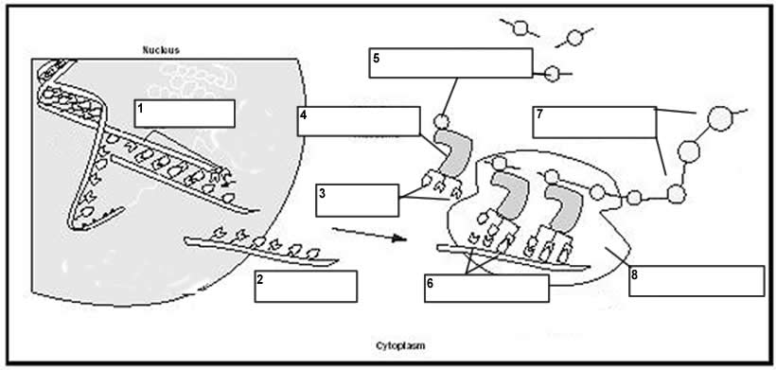
- Use your textbook or notes to put the appropriate labels in the boxes that describe the process of translation.
polypeptide chain DNA tRNA mRNA
codon ribosome amino acid anticodon

