Name: ________________________ Period: ___ Date: __________
From Gene to Protein
Objectives: In this activity you will follow a series of DNA base codes through transcription and translation
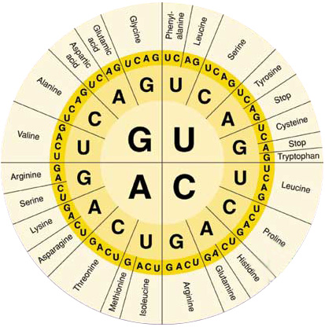
Vocabulary: gene, nucleotide, polypeptide, mRNA
Procedure:
- Use the data table below to complete the following steps.
- Complete column B by writing the correct mRNA codon for each sequence of DNA bases listed in the column marked DNA Base Sequence. Use the letters A, U, C, and G.
- Identify the process responsible by writing its name in column A.
- Complete column D by writing the correct anticodon that binds to each codon from codon B.
- Identify the process responsible by writing its name on the arrow in column C.
- Complete column E by writing the name of the correct amino acid that is coded by each base sequence. Use the Universal Genetic Code wheel to translate the mRNA base sequences to amino acids.
Data Table
 | A | B | C | D | E
DNA Base Sequence | Process | mRNA Codon | Process | tRNA Anticodon | Amino Acid
AAT
GGG
ATA
AAA
GTT
Analyze and Conclude:
- Where within the cell…
  - are the DNA instructions located? __________________________________________
  - does transcription occur? _________________________________________________
  - are ribosomes located? __________________________________________________
  - does translation occur? ___________________________________________________
- Explain why specific base pairing is essential to the processes of transcription and translation?
__________________________________________________________________________________________________________________________________________________________________________________________________________________________________________

