+

Biology

Topic 17 – Immune System Chapter 35 pages 1009-1033
Power Notes

SC.912.L.14.52 – Immune System  ______________________________  ______________________________  ______________________________  ______________________________  ______________________________  ______________________________  ______________________________  ______________________________  ______________________________  ______________________________  ______________________________  ______________________________  ______________________________  ______________________________  ______________________________  ______________________________  ______________________________  ______________________________  ______________________________  ______________________________  ______________________________  ______________________________  ______________________________  ______________________________  ______________________________  ______________________________  ______________________________  ______________________________  ______________________________  ______________________________  ______________________________  ______________________________  ______________________________ | MAIN IDEA: The immune system has several defenses against pathogens and foreign cells.  Nonspecific Defense Specific Defense  Examples Examples  MAIN IDEA: Many body systems and structures protect you from pathogens.  Part How It Contributes to the Immune System  Circulatory system  Skin  Mucous membrane  Body secretions  Phagocyte  (macrophage)  Fever  T cell  B cell  Antibody  Interferon

______________________________  ______________________________  ______________________________  ______________________________  ______________________________  ______________________________  ______________________________  ______________________________  ______________________________  ______________________________  ______________________________  ______________________________  ______________________________  ______________________________  ______________________________  ______________________________  ______________________________  ______________________________  ______________________________  ______________________________  ______________________________  ______________________________  ______________________________  ______________________________  ______________________________  ______________________________  ______________________________  ______________________________  ______________________________  ______________________________  ______________________________  ______________________________  ______________________________  ______________________________  ______________________________  ______________________________  ______________________________  ______________________________ | MAIN IDEA: Many body systems work to produce an inflammatory response.  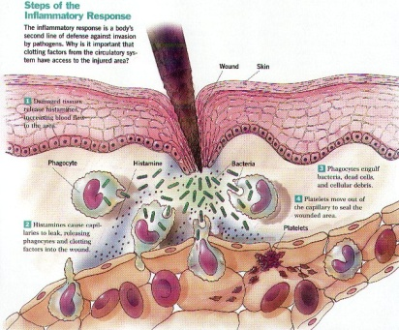  Inflammatory response  is triggered by  which release  which  which attracts  which causes  which causes  which causes  which causes  which  c  c  c  MAIN IDEA: Cells of the immune system produce specific responses.  Active Immunity Passive Immunity  Both

