Invasive Species
Student Worksheet

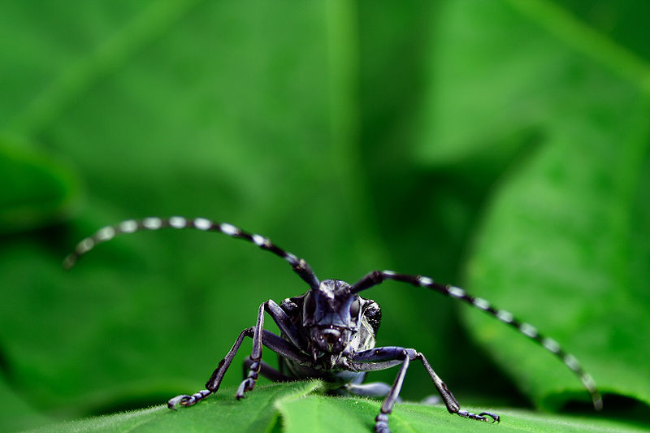
Asian long-horned beetle (Anoplophora glabripennis).
Kyle T. Ramirez © Kyle T. Ramirez

Introduction

Invasive Species

A species that establishes itself in an area that is outside its natural range is called a non-native or alien species. If it begins to harm its new environment, it is said to be invasive. Invasive species have become a growing problem worldwide as global travel and trade increase.

After habitat loss, invasive species are the second-greatest threat to biodiversity and a major cause of extinctions. They can also be extremely damaging to the economy and to human health. Introduced species in Canada (2004 data) include
• at least one-quarter of all plants
• 181 insects that feed on woody plants
• 24 birds
• 26 mammals
• 55 freshwater fish
• 2 reptiles
• 4 amphibians
• several fungi
• several molluscs.

Some of these introduced species, such as Dutch elm disease, purple loosestrife, the gypsy moth and the zebra mussel are especially well known for their invasiveness. They are considered to be among the world’s “worst” invasive pests.

The first invasive species in North America arrived with European explorers and settlers. Today, new species are continually arriving by land, air and sea. Invasive species enter new territory by hitchhiking on goods, packaging materials and transportation vehicles such as planes, ships and cars. In other cases, they arrive directly through trade in the agricultural, horticultural and pet industries. Only later are they discovered to be invasive.

Not all introduced species become invasive. In fact, most introduced species do not cause harm, and some may even be beneficial. Many of our domestic animals and crops are introduced. While it is not always clear what causes an introduced species to become invasive, one theory is that the lack of natural predators and diseases allow the population to grow unchecked.

Once an invasive species becomes established, it can damage the environment by preying on, parasitizing or competing with native species. This affects the delicate balance of the affected ecosystem. Water and nutrient cycles can be affected, as well as vital ecosystem functions such as water filtration (by wetlands) or greenhouse-gas absorption (by forests). Often, the damage caused cannot be reversed. Some invasive species—such as West Nile virus—even kill humans and animals directly.

The far-reaching effects of invasive species make it difficult to measure their full economic impact. In Canada, it is estimated that $7.5 billion is lost each year from invasive forest and agricultural pests alone. This figure includes direct losses caused by the pests, as well as the millions of dollars spent trying to control them.

An Example: The Zebra Mussel

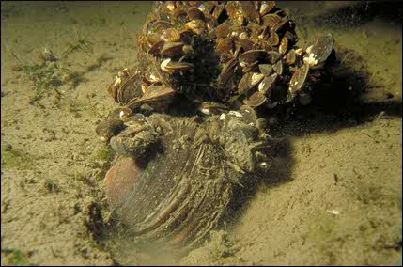
Zebra mussels (Dreissena polymorpha) attached to
a native mussel.
André Martel © Canadian Museum of Nature

Zebra mussels (Dreissena polymorpha) have been in Canada since 1988 and they continue to cause serious repercussions in rivers and lakes. They came originally from the waters around the Caspian Sea in countries such as the Netherlands, Bulgaria and Russia. They likely found their way to North America and other parts of the world in ship ballasts.

Zebra mussels were first detected in North America in Lake St. Clair, Ontario, in 1988. Since then, they've spread throughout lakes and rivers associated with the Great Lakes, and throughout much of the eastern half of the United States. The U.S. government has taken steps to prevent further spread. For example, it is illegal to drive on a highway with a boat whose hull has zebra mussels attached to it.

Zebra mussels live about two years and reach three centimetres in length. They typically produce between 20 000 and 50 000 eggs a season, and sometimes even up to one million eggs! Their larvae are released into the water and swim to a suitable habitat, where they attach themselves to rocks, shells, or any hard surface. Hundreds of thousands of these mussels can live in one square metre.

They are active filter feeders and can filter up to one litre of water a day. They can “clean” a lake or river of its algae, plankton and detritus—basically the entire microscopic food supply for all other organisms!

Zebra mussels stick themselves to the surface with a kind of cement that is very difficult to get off. They will grow on any hard surface, including the shells of freshwater clams, the hulls of boats, inside and outside pipes, etc.

Activity 1: Invasive Species and Biodiversity

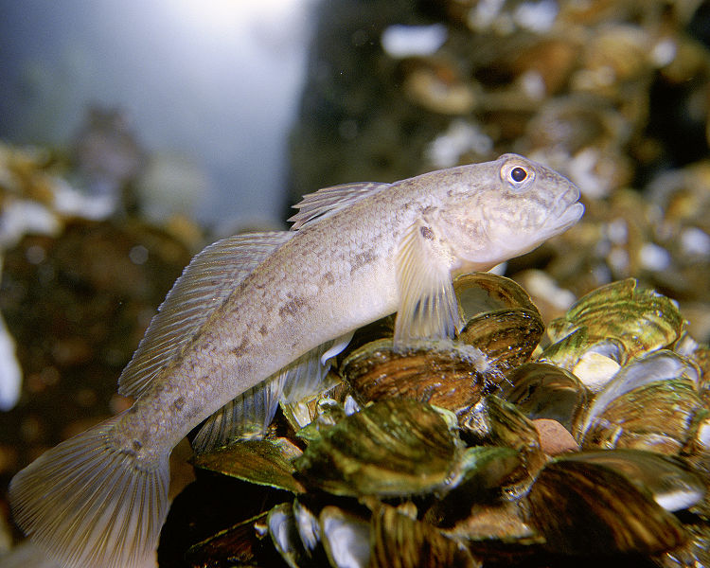
Round Goby (Neogobius melanostomus).
Eric Engbretson, U.S. Fish and Wildlife Service © Public domain

Watch the video The Invaders (Invasive Species), which shows Canadian Museum of Nature scientist André Martel talking about the impact that an invasive species can have on a river, and answer the following questions.
• Video: The Invaders (Invasive Species) (3 min. 1 sec.)
http://nature.ca/en/teacher-zone/teacher-resources/animations-videos/video-invaders-invasive-species

1.1 What can happen to native species when you introduce an exotic, or non-native, species?

1.2 Why is species diversity important?

Activity 2: Exponential Population Growth

Watch the animation Invasive Species and Exponential Population Growth, which illustrates zebra-mussel population growth, and answer the following questions.
• Animation: Invasive Species and Exponential Population Growth
http://nature.ca/en/teacher-zone/teacher-resources/animations-videos/invasive-species-exponential-population-growth

2.1 List two ways that invasive species can out-compete native species.

2.2 What happened to the number of zebra mussels in Ontario’s Rideau River between 1993 and 1996?

Activity 3: Asking Questions about Invasive Species

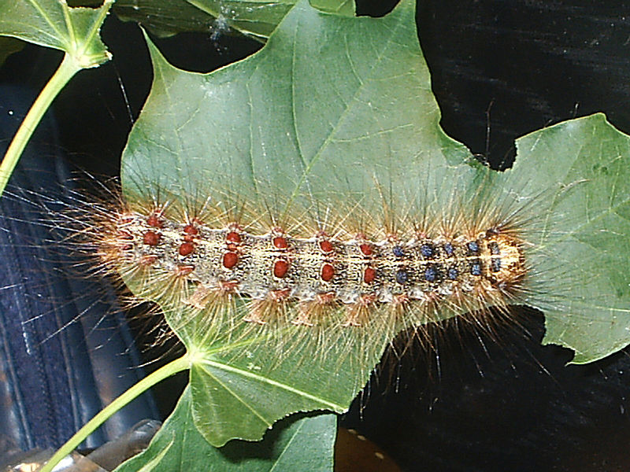
Gypsy-moth caterpillar (Lymantria dispar).
Tonio H. © Tonio H.

View the PowerPoint about asking open versus closed questions.
• PowerPoint: Invasive Species: Asking Questions
http://nature.ca/education/_doc/especes-env_e.ppt

3.1 Using the T chart, write four closed and four open questions about invasive species.

• T chart (PDF)

http://nature.ca/education/pdf/questions_tableau_e.pdf

Activity 4: Research Report

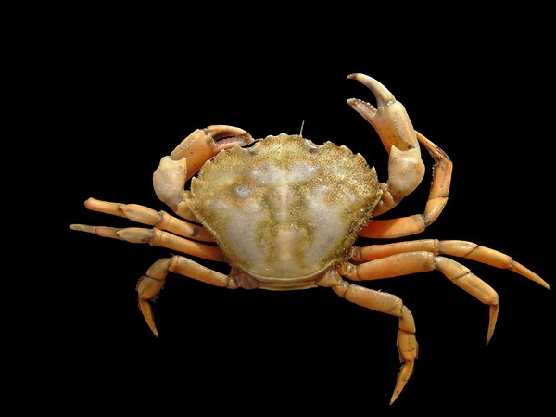
European green crab (Carcinus maenas).
Hans Hillewaert © Hans Hillewaert

4.1 Pick one of your open questions to be the subject of a report that you will prepare.

Use the Connecting Questions Template at the end of this worksheet to help you in thinking about your question.

In the centre circle, write an open question that will require some predicting and thinking about what might happen, based on information that you currently have. Then, fill the other circles with potential outcomes resulting from the answer to the question.

The idea is to think about how each change could affect something else, so what happens in one circle would directly affect the circle next to it. Add arrows as needed to indicate these relationships.

4.2 Using what you have learned and the suggested web sites listed below or other reliable sources of information, research your question and prepare a written report.

The report should be two to three pages long and based on at least three different sources of information.

4.3 Prepare to present your paper to the class. The presentation should be about 10 minutes long. Check with your teacher to see what possible formats you may use for your presentation.

Additional Resources

• Canadian Biodiversity: Ecosystem Status and Trends 2010

http://www.biodivcanada.ca/default.asp?lang=En&n=83A35E06-1

• Invasive Alien Species in Canada

http://www.ec.gc.ca/eee-ias/default.asp?lang=En&n=C4637128-1

• Exotic Species in the Rideau River

http://nature.ca/rideau/b/b9-e.html

• A Canadian Action Plan to Address the Threat of Aquatic Invasive Species

http://www.dfo-mpo.gc.ca/science/enviro/ais-eae/plan/plan-eng.htm

• Invasive Alien Species in Canada

http://www.hww.ca/hww2.asp?id=220

• Wildlife and Nature

https://www.ontario.ca/page/wildlife-and-nature

• Case Study 4.1—The Zebra Mussel Is a Well Known Invader, 2002 October Report of the Commissioner of the Environment and Sustainable Development

http://www.oag-bvg.gc.ca/internet/English/att_c20021004se01_e_12345.html

Connecting Questions Template

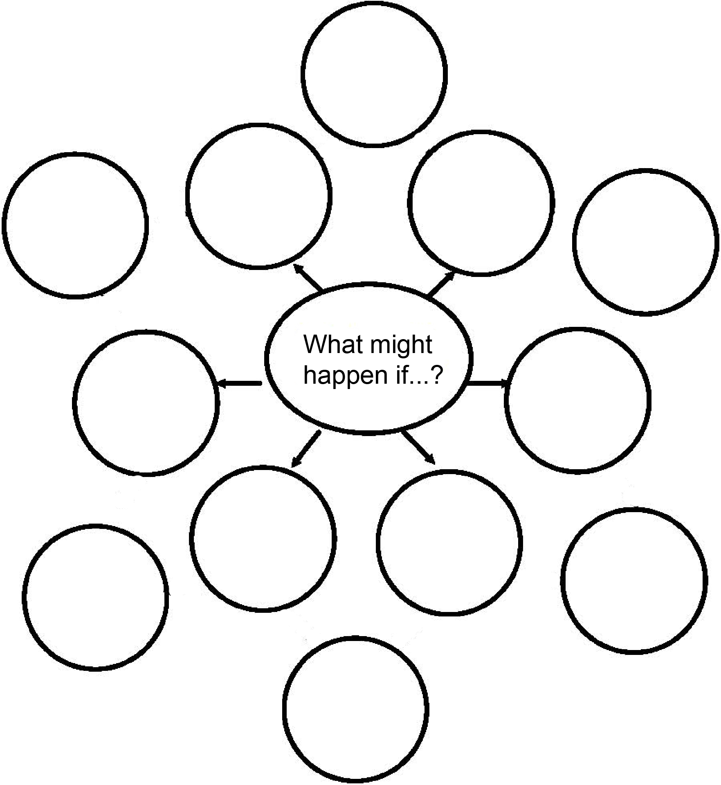

http://nature.ca/en/teacher-zone/teacher-resources/lessons/lesson-invasive-species

