Name: ___________________________________________ Per: _____ Date: ___________
Instructions: Use your power notes and the article to answer the questions within and after the article.
Bonobos Join Chimps as Closest Human Relatives
13 June 2012 1:30 pm
Max Planck Society
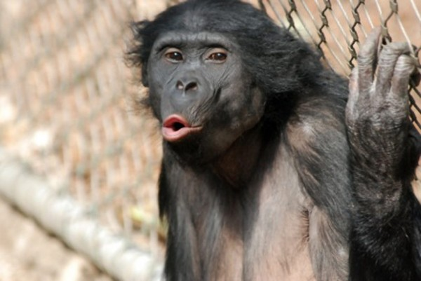
Chimpanzees now have to share the distinction of being our closest living relative in the animal kingdom. An international team of researchers has sequenced the genome of the bonobo for the first time, confirming that it shares the same percentage of its DNA with us as chimps do. The team also found some small but tantalizing differences in the genomes of the three species—differences that may explain how bonobos and chimpanzees don't look or act like us even though we share about 99% of our DNA.
"We're so closely related genetically, yet our behavior is so different," says team member and computational biologist Janet Kelso of the Max Planck Institute for Evolutionary Anthropology in Leipzig, Germany. "This will allow us to look for the genetic basis of what makes modern humans different from both bonobos and chimpanzees."
Ever since researchers sequenced the chimp genome in 2005, they have known that humans share about 99% of our DNA with chimpanzees, making them our closest living relatives. But there are actually two species of apes that are this closely related to humans: bonobos (Pan paniscus) and the common chimpanzee (Pan troglodytes). This has prompted researchers to speculate whether the ancestor of humans, chimpanzees, and bonobos looked and acted more like a bonobo, a chimpanzee, or something else—and how all three species have evolved differently since the ancestor of humans split with the common ancestor of bonobos and chimps between 4 million and 7 million years ago in Africa.
- Do you think humans, bonobos, and chimps have similar genomes? Why or why not?

When the Max Planck scientists compared the bonobo genome directly with that of chimps and humans, however, they found that a small bit of our DNA, about 1.6%, is shared with only the bonobo, but not chimpanzees. And we share about the same amount of our DNA with only chimps, but not bonobos. These differences suggest that the ancestral population of apes that gave rise to humans, chimps, and bonobos was quite large and diverse genetically—numbering about 27,000 breeding individuals. Once the ancestors of humans split from the ancestor of bonobos and chimps more than 4 million years ago, the common ancestor of bonobos and chimps retained this diversity until their population completely split into two groups 1 million years ago. The groups that evolved into bonobos, chimps, and humans all retained slightly different subsets of this ancestral population's diverse gene pool—and those differences now offer clues today to the size and range of diversity in that ancestral group.
- What do you think the word “genome” refers to when talking about DNA structure: the sugar-phosphate backbone or the nitrogenous bases? Why or why not?

While the function of the small differences in DNA in the three lineages today is not yet known, the Max Planck team sees clues that some may be involved in parts of the genome that regulate immune responses, tumor suppression genes, and perception of social cues. The common chimpanzee, for example, shows selection for a version of a gene that may be involved in fighting retroviruses, such as HIV—a genetic variant not found in humans or bonobos, which may explain why chimps get a milder strain of HIV (called simian immunodeficiency virus) than humans do. Another difference is that bonobos and humans, but not chimps, have a version of a protein found in urine that may have similar function in apes as it does in mice, which detect differences in scent to pick up social cues.
- Why do chimps get a milder strain of HIV than humans?

"This paper is a significant benchmark achievement that lays the groundwork for other types of investigations into Homo-Pan differences," says molecular anthropologist Maryellen Ruvolo of Harvard University, who was not involved in the work. As researchers study the genome in more depth, they hope to find the genetic differences that make bonobos more playful than chimps, for example, or humans more cerebral. The bonobo genome also should put to rest arguments that humans are more closely related to chimps, says primatologist Frans de Waal of Emory University in Atlanta. "The story that the bonobo can be safely ignored or marginalized from debates about human origins is now off the table," says de Waal.

- A newly-made DNA molecule has
  - Two new strands
  - Two strands from two parent DNA molecule
  - One new strand
  - One new strand and one strand from the parent DNA molecule

- The nitrogenous base adenine pairs with which of the following nitrogenous bases?
  - Guanine
  - Thymine
  - Cytosine
  - Uracil

- There are ____ bonds between the nitrogenous bases cytosine and guanine.
  - One
  - Two
  - Three
  - Four

- DNA is a
  - Protein
  - Carbohydrate
  - Nucleic acid
  - Lipid

- Construct the complementary (pairing) strand on the left side of the following DNA molecule:
T
A
T
G
C

