Name: ___________________________ Period: ____ Date: ________
Genetic Changes: Mutations
Benchmark: SC.912.L.16.4 – Explain how mutations in the DNA sequence may or may not result in phenotypic change. Explain how mutations in gametes may result in phenotypic changes in offspring.
Learning Objectives: Students will (1) describe gene and chromosomal mutations in the DNA sequence, and (2) explain how gene and chromosomal mutations may or may not result in a phenotypic change.
Essential Question: The chemicals in cigarette smoke are known to cause cancer. Propose a series of steps that could lead to development of lung cancer in a smoker.
WHAT ARE MUTATIONS?
Now and then cells make mistakes in copying their own DNA, like inserting an incorrect base or skipping a base as the new strand is put together. _________________ are changes in the genetic material.
Mutations that produce changes in a single gene are known as ____________ mutations.
Mutations that produce changes in whole chromosomes are known as ____________________ mutations.
Mutations in eggs or sperm affect future generations by producing offspring with new characteristics. They may result in embryo not surviving or providing organism with an advantage. Mutations in body cells affect only the individual and may result in cancer.
WHAT ARE SOME TYPES OF GENE MUTATIONS?
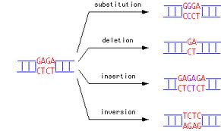
Gene mutations involving changes in one or a few nucleotides are known as __________
mutations. Point mutations occur at a _________ point in the DNA sequence. Point mutations include:
- __________________, in which one base is changed to another.
- __________________, in which a base is inserted from the DNA sequence
- __________________, in which a base is removed from the DNA sequence.
The insertion or deletion of a nucleotide results in a shift in the “reading frame” of the genetic message causing a __________________ mutation. Frameshift mutations may change every __________________ that follows the point of mutation; thus altering a protein so much that is ______________ to perform its normal function.
Recall and Practice: With your elbow partner, find the products of translation for the following DNA sequences. Identify the type of point mutation.

TACAAACCGAACATT
TACAAATCGAACATT
A
TACAAACCTAACATT

TACAACACCGAACATT
TACAACCGAACATT
WHAT ARE CHROMOSOMAL MUTATIONS?
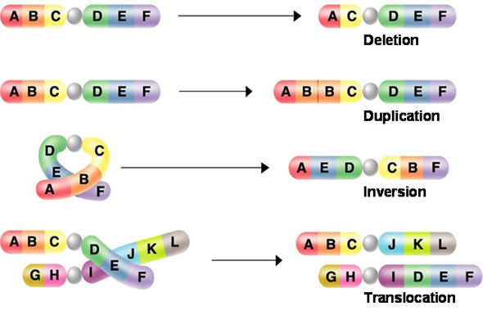
____________________ mutations involve changes in the number or structure of chromosomes. Such mutations may change the locations of genes on chromosomes, and may even change the number of copies of some genes.
The most important of these mutations are illustrated in the figure to the right.
- _____________ involve the loss of all or part of a chromosome.
- _____________ produce extra copies of part of a chromosome.
- _____________ reverse the direction of parts of chromosomes.
- _____________ occurs when parts of one chromosome breaks off and attaches to another.
Few chromosomal mutations are passed on to the next generation because the zygote usually dies. In cases where the zygote lives and develops, the mature organism is often sterile and thus incapable of producing offspring.
Check Your Understanding: Name the type of mutation involved in each of the following cases.
- Guanine has been “erased” from the nucleotide sequence. _________________
- Cytosine was added between thymine and guanine. _________________
- Some genes are duplicated on the same chromosome. _________________
- Part of a chromosome break off and attaches to a different one. _________________
- Adenine is replaced by thymine in a nucleotide sequence. _________________
WHAT IS THE SIGNIFICANCE OF MUTATIONS?
Most mutations are _____________, meaning that they have little or no effect on the expression of genes or the function of the proteins for which they code. Mutations that cause dramatic changes in protein structure or gene activity are often ___________, producing defective proteins that disrupt normal biological activities. Mutations are also a source of ______________ variability in a species.
ESSENTIAL QUESTION:
The chemicals in cigarette smoke are known to cause cancer. Propose a series of steps that could lead to development of lung cancer in a smoker.
____________________________________________________________________________________________________________________________________________________________________________________________________________________________________________________________________________________________________________________________________________________________________________________________
Challenge: Gene Mutations and Proteins
Gene mutations often have serious effects on proteins. On this activity, you will demonstrate how such mutations affect proteins synthesis. On a separate sheet of paper complete all the activities below.
- Copy the following base sequence of one strand of an imaginary DNA molecule:
AATGCCAGTGGTTCGCAC
- Then, write the base sequence for an mRNA strand that would be transcribed from the given DNA sequence.
- Use the Genetic Code chart to determine the sequence of amino acids in the resulting protein fragment.
- If the FOURTH base in the ORIGINAL DNA strand were changed from G to C, how would this affect the resulting protein fragment? Show your work.
- If a G were added to the ORIGINAL DNA strand after the THIRD base, what would the resulting mRNA look like? How would this addition affect the protein?
- Which change in DNA was a point mutation? Which was the frameshift mutation?
- How did the frameshift mutation affect the protein?

