Name: ________________________________ Period: ____ Date: _________
Patterns of Inheritance Problems: Monohybrid Crosses
DOMINANCE / recessiveness
 | _____ | _____
_____
_____
- In humans widow’s peak (W) is dominant over straight hairline (w). A heterozygous man for this trait marries a woman who is also heterozygous.
  - What is the genotype for the man? ______
  - What is the genotype for woman? ______
  - What will be the genotype and phenotype of the
first generation?

 | _____ | _____
_____
_____
- Cystic fibrosis is a recessive (f) genetic disorder. Ron is homozygous dominant and Nancy is a carrier of cystic fibrosis?
  - What is the genotype for Ron? ______
  - What is the genotype for Nancy? ______
  - Use a Punnett square to predict the probability
that one of their children will have cystic fibrosis.

- Hornless (H) in cattle is dominant over horned (h). A homozygous hornless bull is mated with a heterozygous cow.
 | _____ | _____
_____
_____
  - What is the genotype of the bull? ______
  - What is the genotype of the cow? ______
  - What will be the genotype and phenotype of the
first generation?

- CHALLENGE : In humans, acondroplasia “dwarfism” (D) is dominant over normal (d). A homozygous dominant (DD) person dies before the age of one. A heterozygous (Dd) person is dwarfed. A homozygous recessive individual is normal. A heterozygous dwarf man marries a dwarf heterozygous woman. What is the probability of having a normal child? What is the probability of having a child that is a dwarf? What is the probability of having a child that dies at one from this disorder?

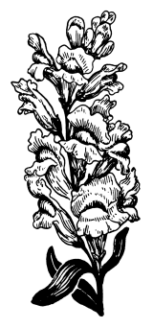
INCOMPLETE DOMINANCE
- In snapdragons, a gene that affects flower color has two alleles: red (R) and white (W). In heterozygous individuals, the phenotype is pink.
 | _____ | _____
_____
_____
  - What is the genotype of a pink flower? ______
  - Show a cross between two pink snapdragons and give the expected genotype and phenotype.

- CHALLENGE In Andalusian fowls, black individuals (B) and white individuals (b) are homozygous. Heterozygous individuals are bluish-gray. What results if a black individual is crossed with a bluish-gray individual? Show the cross as well as the genotypes and phenotypes of the parents and offspring.

CODOMINANCE
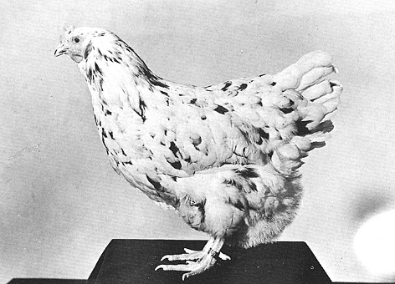
- In some chickens, the gene for feather color is controlled by codominance. The allele for black is B and the allele for white is W. The heterozygous phenotype is known as erminette.
  - What is the genotype for black chickens? ____
  - What is the genotype for white chickens? ____
  - What is the genotype for erminette chickens? ____
  - If two erminette chickens were crossed, what is the probability that:
    - They would have a black chick? ____%
    - They would have a white chick? ____%
    - They would have an erminette chick? ____%

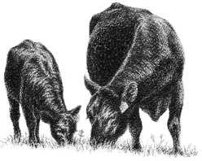
- CHALLENGE In shorthorn cattle, coat color may be red, white, or roan. In roan cattle, their coats are a mixture of red and white hairs, although the animals appear a light rust color from a distance. Show a cross between a roan bull and a red cowe and give the expected genotype and phenotype.

